**Background:**

Birds require periodic maintenance, and we need to build a business plan to deliver it. Please put together a recommendation for a maintenance program.

**Objective:**

The objective is to analyze historical data to discover when a Bird is likely to be triggered for maintenance.

**Findings/Analysis:**

The first step of the analysis is to distinguish which categories may influence a Bird’s chances to trigger a maintenance flag. This can be done by looking at the correlation and mean of each category. Looking at the correlation we can identify 4 categories that have a noticeable positive correlation. (trip_speed, total_distance, num_rides, total_duration).

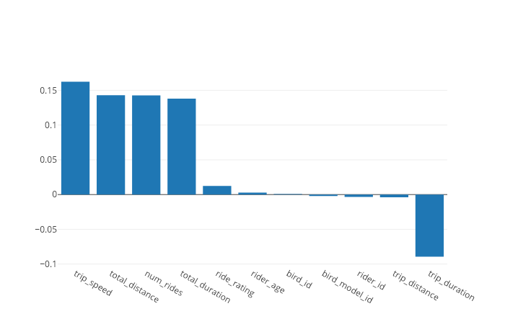

Based on those 4 categories, if we take the averages for triggered and non-triggered Birds, we can see a difference between the averages. In these categories, triggered Birds have higher values than non-triggered Birds. From this we can assume that these categories are likely important factors of Birds that get triggered for maintenance. Example: Birds triggered for maintenance received a greater number of rides on average than Birds that did not get triggered.

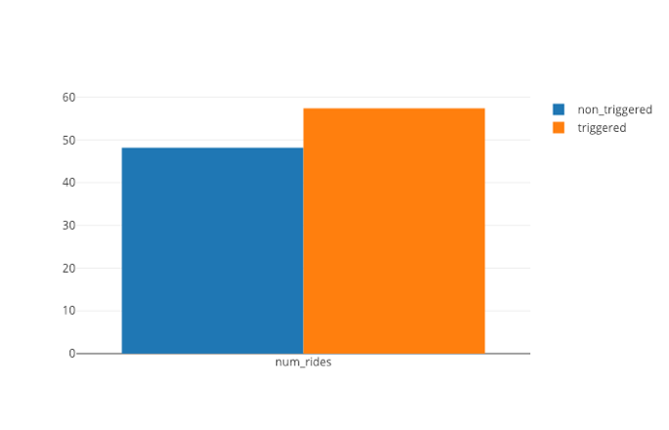 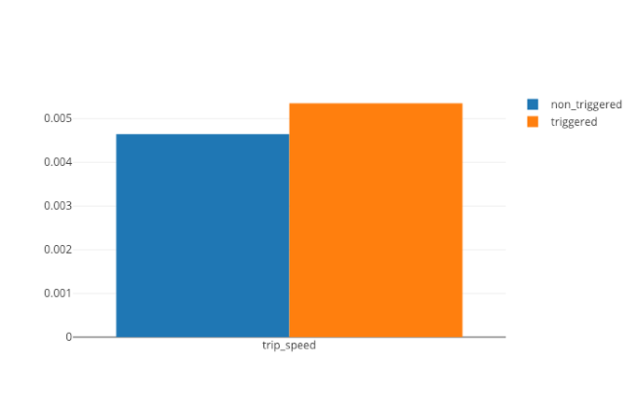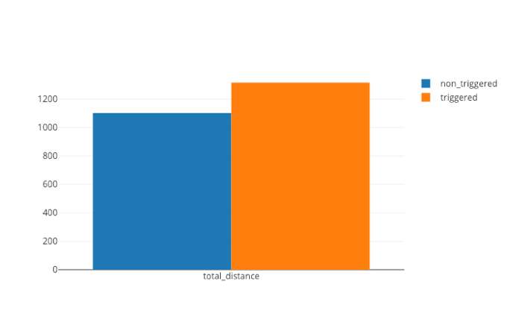 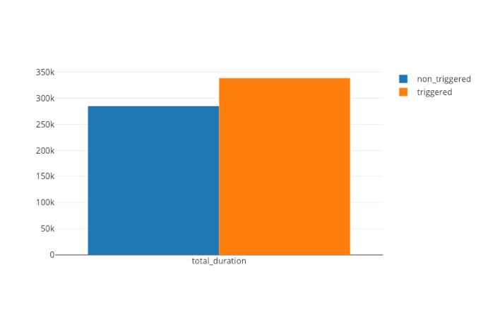

When we look at the distribution of these categories, we can see that there is an inverse relationship. This relationship shows that as the values of these categories increase, non-triggered Birds decrease, and triggered Birds increase. Meaning that Birds require more maintenance when these categories increase. In addition to this, each distribution has an identifiable threshold where the triggered Birds began to increase.

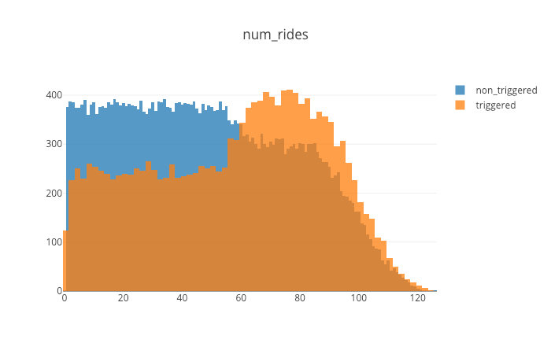 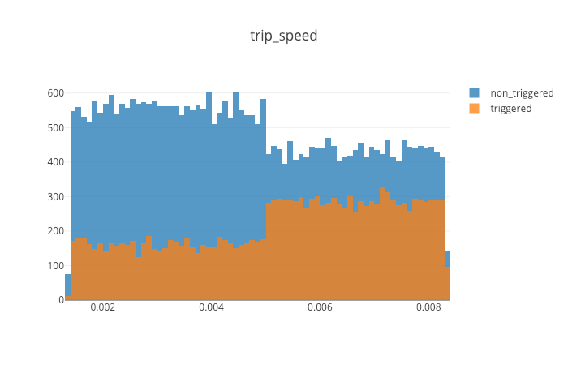

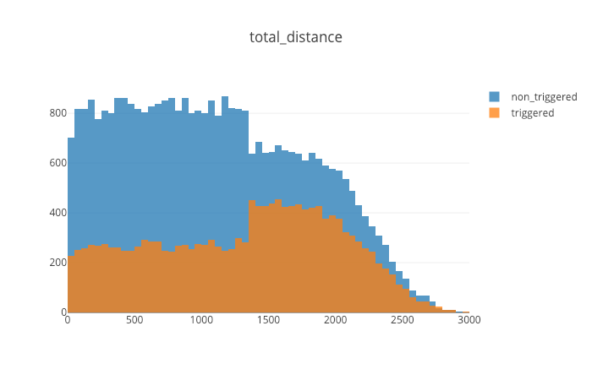 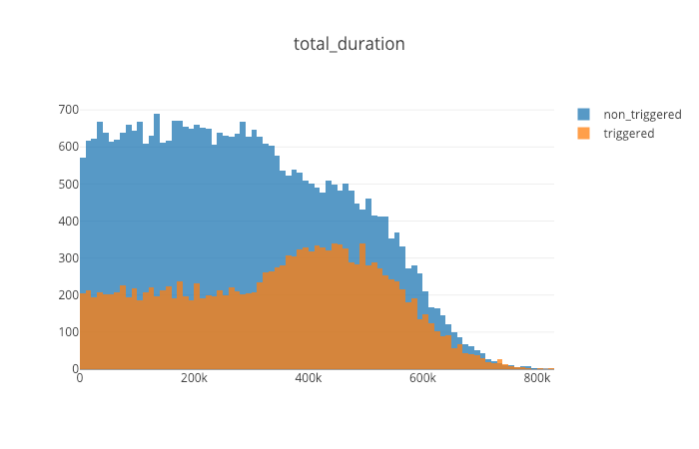

**Conclusion:**

Based on the findings above, we can conclude that there are 4 categories with identifable thresholds that can be used to distinguish when a Bird is likely to be triggered for maintenance. Below are the 4 categories and their respective thresholds.

* Trip_speed > 0.005
* Total_distance > 1300
* Total_duraiton > 350K
* Num_rides > 60

**Recommendation:**

It is my recommendation that when a Bird meets all of the above thresholds, it should be brought in for maintenance as it will likely be triggered for maintenance in the future.